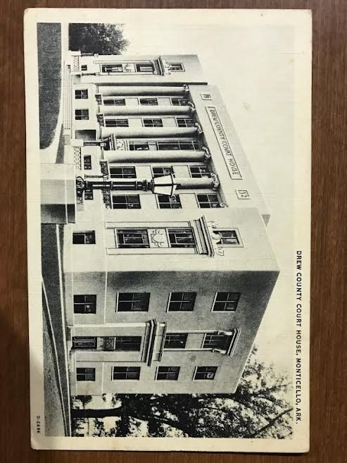 |  | 
Jessie L. Griffin
210 South Main Street- Monticello, Arkansas- 870-460-6200
FAX - 870-412-1134 -drewcojudge@gmail.com

AGENDA
MONDAY, APRIL 13, 2026
DREW COUNTY QUORUM COURT
DISTRICT COURT BUILDING – 6:00 PM

Invocation---County Judge
Pledge of Allegiance— County Judge
Roll Call of Attendance—County Clerk
Approval of the Agenda
Vote on---Roll Call--- County Clerk
Minutes of Previous Meeting---County Clerk
Approval of Minutes from Last Meeting----Roll Call and/or Voice vote—County Clerk
Treasurer’s Report---County Treasurer
Approval of Treasurer’s Report---Roll Call and/or Voice vote---County Clerk
Judge’s Comments – $3423 available from SEAEDD for recycle purchase. Would like a vote for using this for purchase of magnet for Landfill
Have Quorum members contacted water associations regarding fees for VFD
Diana Harton re-appointment to Equalization Board

Reports from Committees –
Briefing and Information -
Old Business
New Business

- Decision on Total Amount for Yearly Distribution for Grants in Aid
- Resolution Number 2026-04 Recognizing Public Safety Telecommunicators
- Appropriation Ordinance 2026-16 for Camera System for the Jail
- Quorum Members--- Additional Comments if needed—Justices of Peace/Elected

ADJOURNMENT----VOTE

